**CTC DASHBOARD**

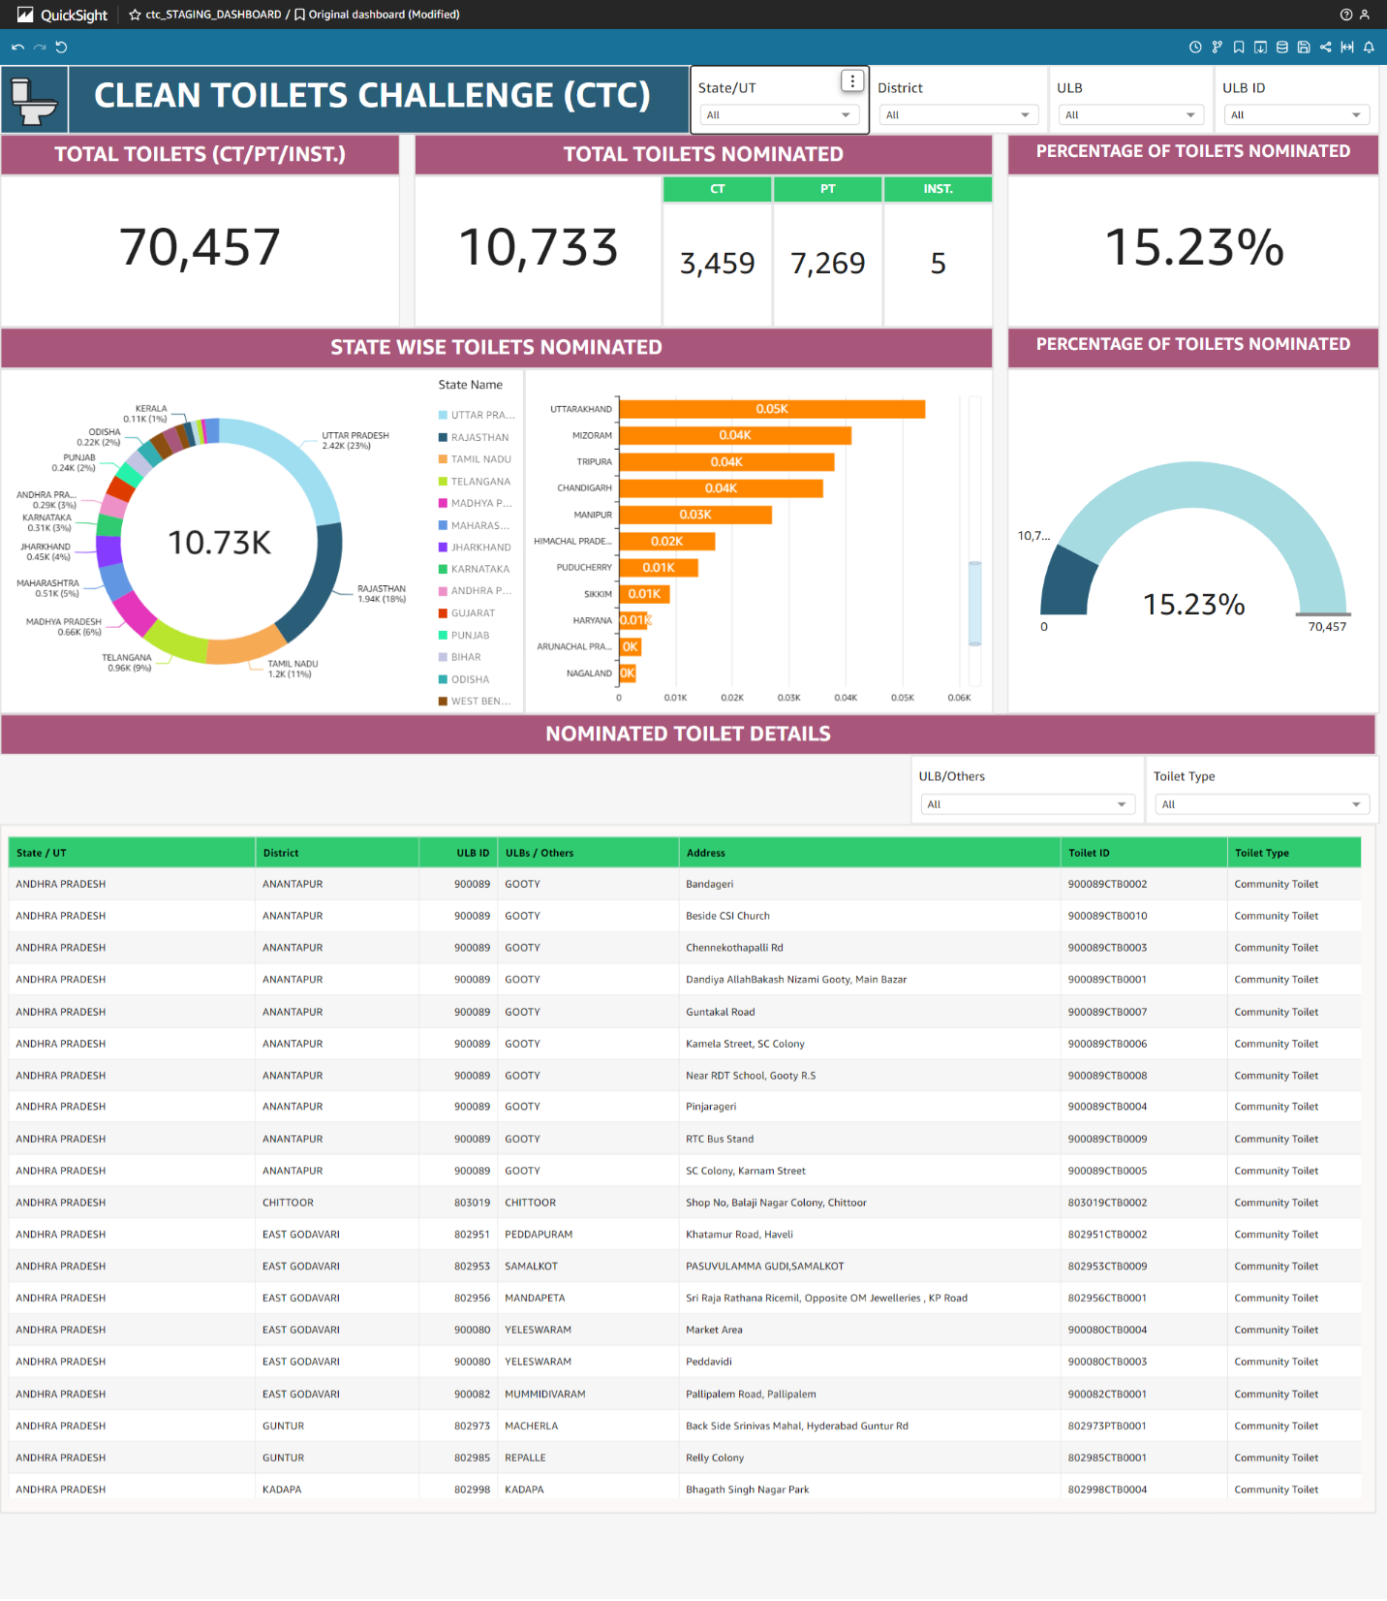

Following Dashboard is made from:

1. system_settings (Database)

* states (Table)
* name (State_Name)
* code (State_Code)
* ULBs (Table)
* name (ULB_Name)
* census_code (ULB_Code)
* districts (Table)
* name (District_Name)
* code (District_Code)

1. gtl (Database)

* toilet_details (Table)
* ulb_id (ULB_ID)
* toilet_id (Toilet_ID)
* isNominated (Nominated)
* category_id (Category)
* is AddedByOtherCTC

**Query:**

SELECT s.name AS State_Name,s.code AS State_Code,d.name AS District_Name,

d.code AS District_Code,u.name AS ULB_Name,u.census_code AS ULB_Code,

t.ulb_id AS ULB_ID, t.toilet_id AS TOILET_ID, t.isNominated AS Nominated,

cast(t.category_id AS unsigned) As Category, CASE WHEN t.isAddedByOtherCTC=1 THEN 'Others' ELSE 'ULB' END AS 'Others',

CASE WHEN u.isMillionPlusCity=1 THEN 'MillionPlus City' ELSE 'Other City' END AS 'MillionPlus City',CASE WHEN u.isCapitalCity=1 THEN 'Capital City' ELSE

'Other City' END AS 'Capital City', t.address AS Adress FROM

system_settings.states AS s

LEFT JOIN system_settings.ULBs AS u ON s.code = u.state_code LEFT JOIN

system_settings.districts AS d ON u.district_code = d.code LEFT JOIN

gtl.toilet_details AS t ON t.ulb_id = u.census_code WHERE t.category_id != 3 AND t.functional_status = 1 AND t.isDelete = 0 AND s.code != 99 AND u.code not in (111222,900488,900484,900049,900050,900051,900508,900509,900839,900674,900118,900119,900120,900381,900502,700001,801084,900734,800888,801236,900504,900817,900128,802632,900197,802633,802478,802494,802523,

802615,900091,803699,803796,803603,803343,803344,803890,803346,803347,803348,

803353,803354,803355,803356,803916,803935,888880,888881,888882,888883,888884,

888885,888886,777777,333333,987654);

There are 4 filters which are in all visuals:

* State_Name
* District Name- In this data filter go to Format Control>>Control Options>>Show relevant values only>>Sate/UT(Dropdown)
* ULB- In this data filter go to Format Control>>Control Options>>Show relevant values only>>Sate/UT(Dropdown) and District (Dropdown)
* ULB_ID- In this data filter go to Format Control>>Control Options>>Show relevant values only>>Sate/UT(Dropdown) and District (Dropdown)

1. **Total toilets(CT/PT/Inst.):**

It contains total Toilets containing CT, PT and Institutional.

1. **Total toilets Nominated:**

Total Nominated toilets is the sum of isNominated = 1.

* To count CT we have created Calculated Field sumIf(Nominated, Category= 1)
* To count PT we have created Calculated Field sumIf(Nominated, Category= 2)
* To count Institutional we have created Calculated Field sumIf(Nominated, Category= 4)

1. **Percentage of Toilets Nominated:**

It is calculated as (sum(Nominated)/count({TOILET_ID})*100)

1. **State wise Toilets Nominated:**

* Donut Chart contains State_Name in Group/Color and Nominated(Sum) in Value.
* Horizontal Stacked Bar Chart contains State_Name in Y-axis and Nominated(Sum) in Value.

1. **Percentage of Toilets Nominated(Gauge chart):**

Gauge chart contains Nominated(sum) in Value and Toile_ID(count) in Target value.

1. **Nominated Toilets Details:**

Its contains table in which State/UT, District, ULB ID, ULBs/Others, Address, Toilet ID , Toilet type under Group By.

It has two filter:

* **ULB/Others:** In this filter we calculate if isNominatedByOthers = 1 then Others else ULB.
* **Toilet Type:** In this filter we create a calculate d Field ifelse(Category = 1, 'Community Toilet', Category = 2, 'Public Toilet', 'Institutional Toilet')